Use Case 1: Add money to the balance

Step 1. User opens the app.

Step 2. The app shows the UI.

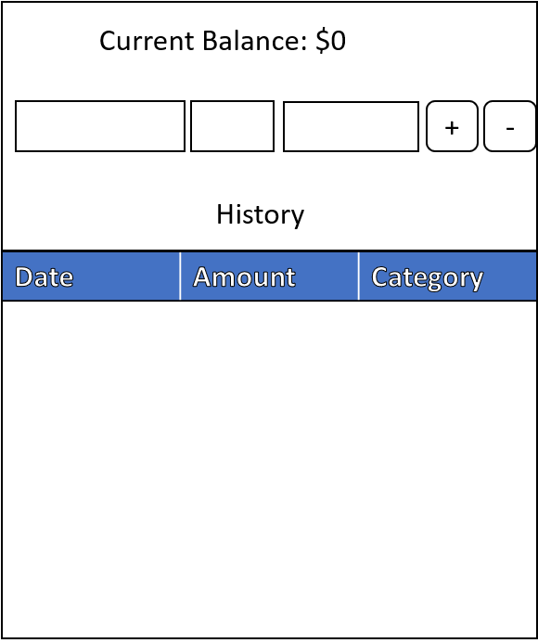

Step 3. User enters the content and click “+” button.

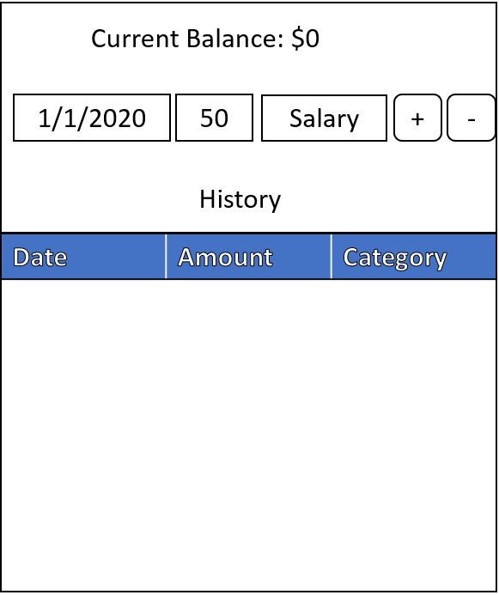

Step 4. The app updates the current balance and shows the transaction in the history table.

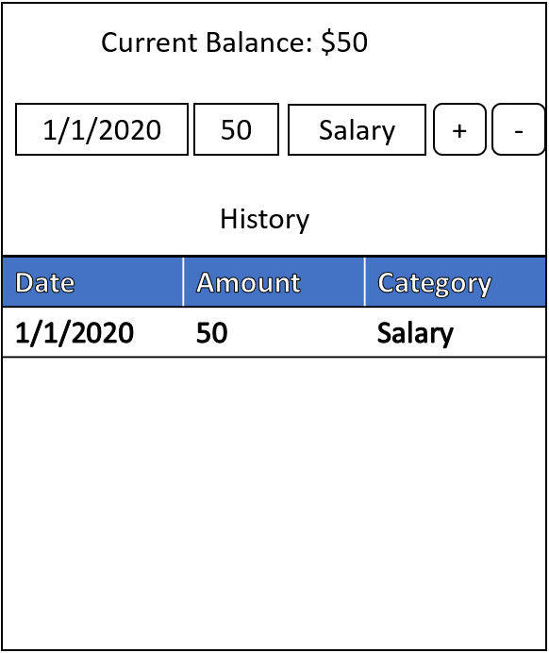

Use Case 2: Spend money from the account

Step 1. User opens the app.

Step 2. The app shows the current balance and history from last time.

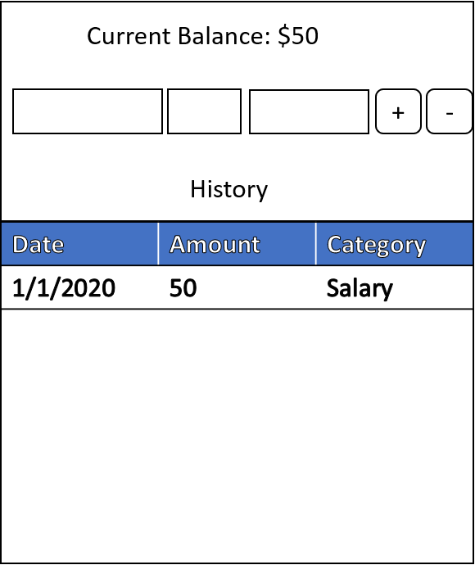

Step 3. User enters the content and click “-” button.

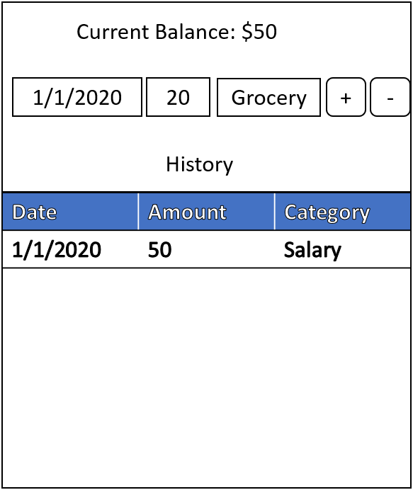

Step 4. The app updates the current balance and shows the transaction in the history table.

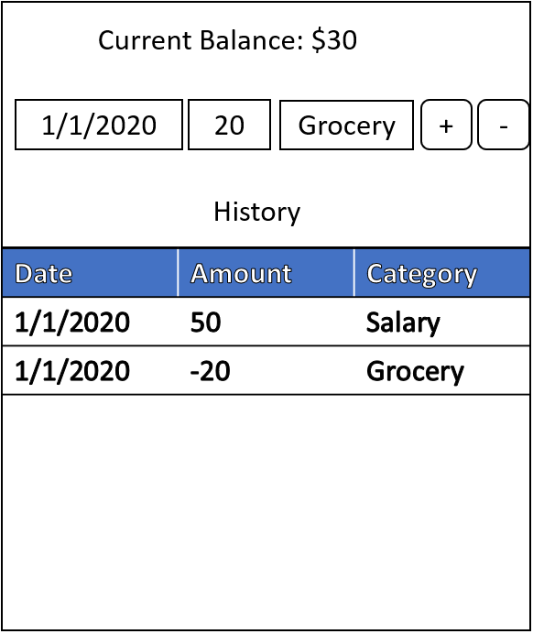

Use Case 2: Check balance and history

Step 1. User opens the app.

Step 2. The app shows the current balance and history from last time

